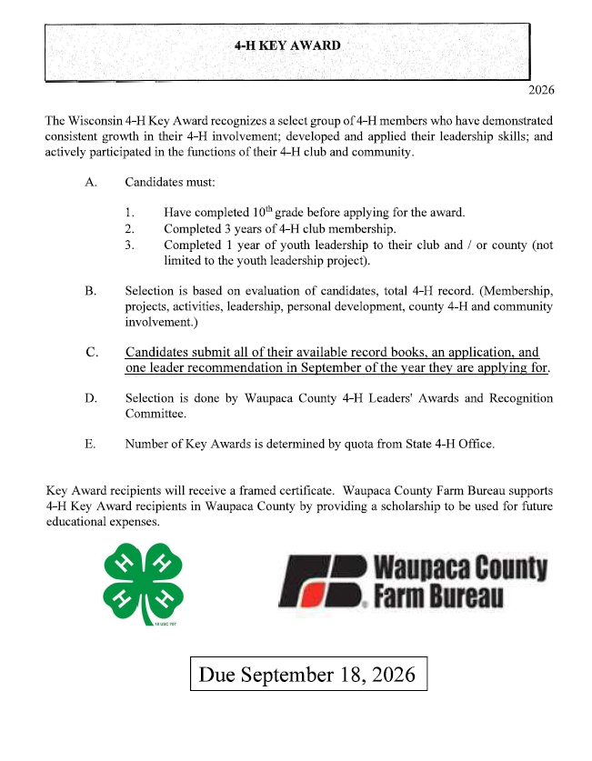

KEY AWARD APPLICATION 2026
Name Yrs. in 4-H
Club Yr. in school Future Plans I have participated/attended the following during my years in 4-H:

Ambassador
National 4-H Congress &/or Conf. Summer Academy
Citizenship Washington Focus/Ignite Space Camp
American Spirit Trip

4-H Camp (Winter or Summer)

4-H Camp or Day Camp Counselor Other (please list)

List 4-H projects and number of years in project (top/most recent 6 projects): Project Yrs.
1.
2.
3.
4.
5.
6.

List non 4-H activities (ex. Church, school, other youth groups) Activity Year/years

Please describe your 4-H club and county involvement (i.e. explain offices held, committees, activities, community service projects, foodstand help, etc.) (you may add an additional page)

Based upon your experiences in 4-H, how has your involvement benefited you?

How will your 4-H involvement help you in developing your leadership and community responsibilities?

Updated 2019

