

2025

The Wisconsin 4-H Key Award recognizes a select group of 4-H members who have demonstrated consistent growth in their 4-H involvement; developed and applied their leadership skills; and actively participated in the functions of their 4-H club and community.

1. Candidates must:
   1. Have completed 10th grade before applying for the award.
   2. Completed 3 years of 4-H club membership.
   3. Completed 1 year of youth leadership to their club and / or county (not limited to the youth leadership project).
2. Selection is based on evaluation of candidates, total 4-H record. (Membership, projects, activities, leadership, personal development, county 4-H and community involvement.)

# C andidates submit all of their available record books, an application, and

o ne leader recommendation in September of the year they are applying for.

1. Selection is done by Waupaca County 4-H Leaders' Awards and Recognition Committee.
2. Number of Key Awards is determined by quota from State 4-H Office.

Key Award recipients will receive a framed certificate. Waupaca County Farm Bureau supports 4-H Key Award recipients in Waupaca County by providing a scholarship to be used for future educational expenses.

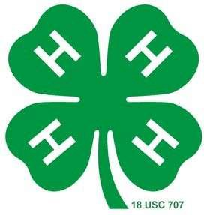

Due September 19, 2025

**KEY AWARD APPLICATION 2025**

Name Yrs. in 4-H

Club Yr. in school

Future Plans

I have participated/attended the following during my years in 4-H:

Ambassador American Spirit Trip

National 4-H Congress &/or Conf. 4-H Camp (Winter or Summer)

State 4-H and Youth Conference 4-H Camp Counselor

Citizenship Washington Focus Other (please list)

Space Camp

List 4-H projects and number of years in project (top/most recent 6 projects): Project Yrs.

1. _

2. _

3. _

4. _

5. _

6. _

List non 4-H activities (ex. Church, school, other youth groups)

A ctivity Year/years

Please describe your 4-H club and county involvement (i.e. explain offices held, committees, activities, community service projects, foodstand help, etc.) (*you may add an additional page)*

Based upon your experiences in 4-H, how has your involvement benefited you?

How will your 4-H involvement help you in developing your leadership and community responsibilities?

Updated 2019