**“HCE…How Sweet It Is”**

Spring HCE Business Meeting, Cultural Arts Event and Recognition Banquet

Waupaca County Association for Home and Community Education

Hosted by the Waupaca Center

Thursday, May 15, 2025Fox Valley Technical College, Waupaca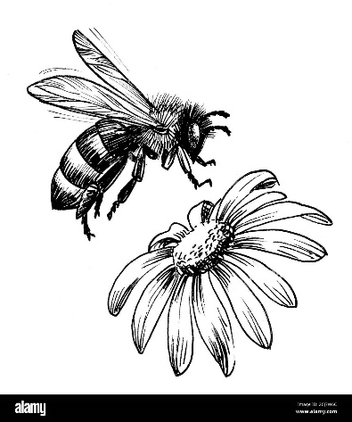

1979 Godfrey Drive, Waupaca

Cost: $15.00* Per Person

**Plan for the day:**

9:15 - 10 a.m. Registration, Beverages, Cultural Arts Check-In

10:00 a.m. HCE Business Meetinghttps://d.adroll.com/cm/index/outhttps://d.adroll.com/cm/n/out\

11:30 Lunch (Hot Roast Beef Sandwich, Choice of Fruit and Vegetable Sides, Potato Salad, Ice Cream Sundae, Beverage Choice)

12:15 Program: The Life and Labors of a Honey Bee

1:00 p.m. Awards Program

2:00 Safe Trip Home

Please bring the following items along:

¤ Your club or individual Pennies for Friendship contribution

¤ Cultural arts contest entries and completed entry forms

¤ Donations for the International Shoebox project (school, cooking, sewing or beauty school small items)

¤ Donations for the Waupaca County Silent Auction Basket (Christmas ornaments or small holiday decor)

Child/teen books will be for sale ($.50-$3.00) proceeds to benefit our Scholarship Program.

%- - - - - - - - - - - - - - - - - - - - - - - - - - - - - - - - - - - - - - - - - - - - - - - - - - - - - - - - - - - - -



Fill out registration below, and mail with payment by May 8, 2025.Make checks payable to: Waupaca County HCE. Registrations are transferable, not refundable. Send registrations to: Judy Long, N2464 Reek Road, Weyauwega, WI 54983 Questions? Please call Judy at 920-867-2888 or Marilyn Herman, 920-596-3594

Club or Individual Names: ___________________________________________________________

_____________________________________________________________________________

How Many: ________ x $15.00 = __________ (*Honorary Members No Charge but please pre-register)