Waupaca County 4-H
Horse and Pony Project
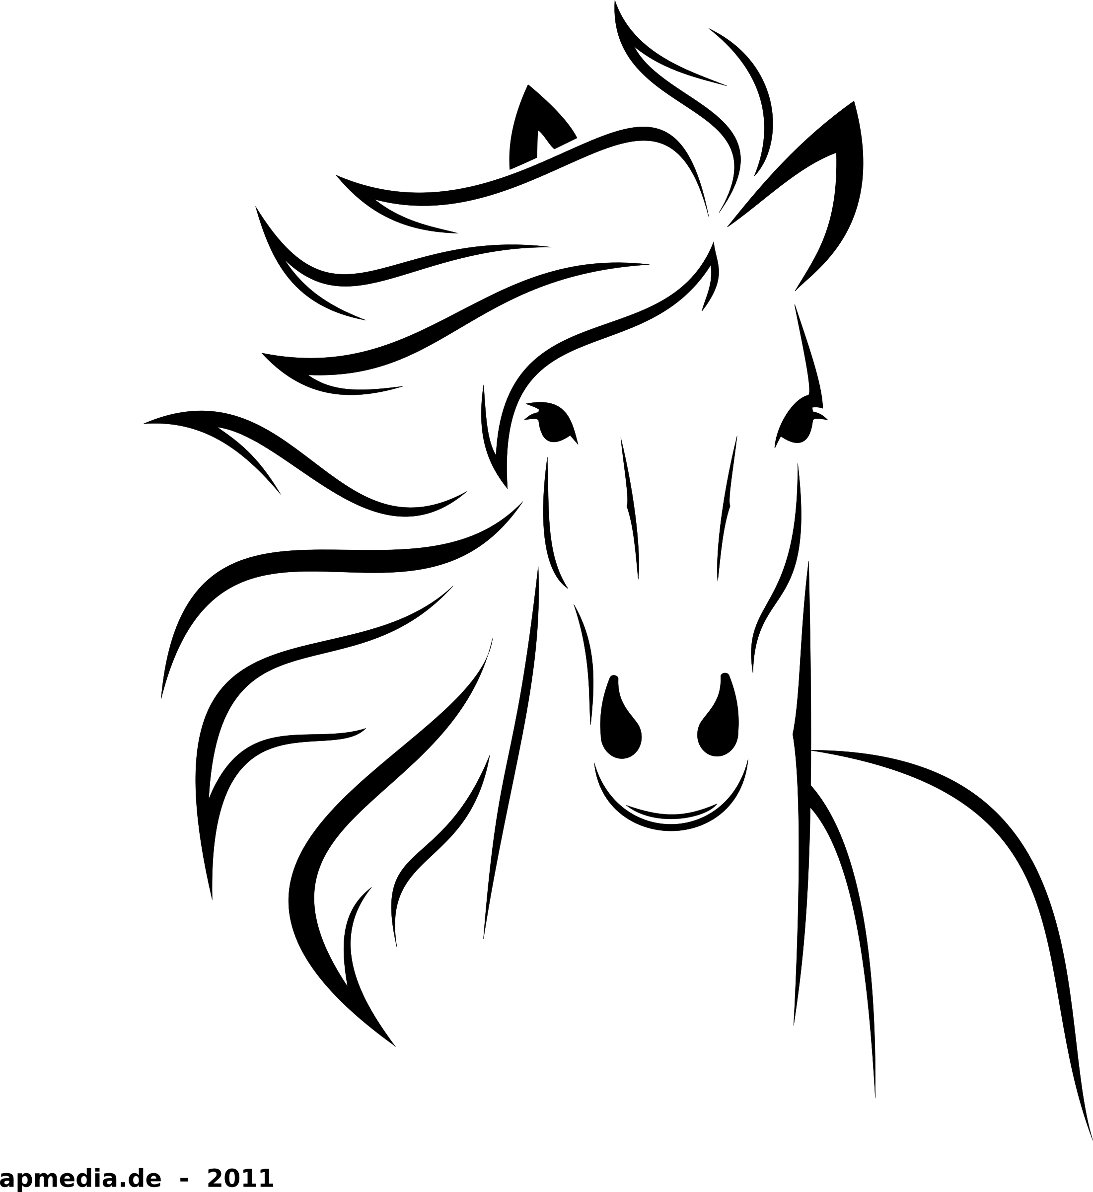

Rules & Guidelines

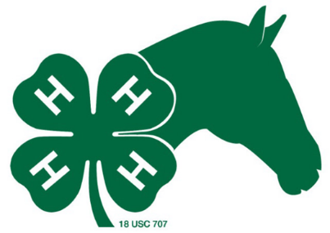

2021

Welcome to the
Waupaca County Horse & Pony Project!

The purpose of this packet is to provide you with information, inform you of important deadlines, rules and guidelines and answer commonly asked questions. Once you and your parents have read this packet, you’ll need to complete the Acknowledgement Form and the Waiver and Release forms and submit those to the Leader Panel before bringing your equine to a work night.

MISSION
The mission of the Waupaca County Horse and Pony Project is to provide opportunities for members to develop life skills, to learn about proper an equine care and foundational horseback riding techniques and skills.

BASIC INFORMATION
First, you don’t need to own an equine to participate! Areas of participation with and without an equine are described under the “Opportunities” section. Enrollment in the Horse or Horseless Horse projects is open to anyone in grades 4 – 13; you must be a member of a Waupaca County Youth Organization. Anyone grade 4 or over may participate with an equine at the Fair. The grade you are in as of January 1st of the exhibit year determines which classes you may enter at the Fair. Please note that while youth can be a member of any Waupaca County Youth Organization, the Project is run through the Waupaca County 4-H Extension and thereby follows the rules and guidelines of 4-H. Since this is a 4-H sponsored project any member from another organization such as FFA or Scouts is not covered by 4-H insurance.

HOW DO I PARTICIPATE?

New enrollments: Anyone enrolling in 4-H for the first time must be enrolled with the Waupaca County Extension Office by February 1st of the exhibit year in order to participate in the Fair and be eligible for awards. Non-4-H members must sign up through their organization by February 1st of the exhibit year.

Re-enrollments: Anyone re-enrolling in 4-H must be enrolled with the Waupaca County Extension Office each 4-H year (Sept. 1 – Aug. 31) by November 15th. Anyone re-enrolling after November 15th will not be eligible for Fair participation; though can participate in work-nights, clinics and the non-fair shows. Non-4-H members must sign up through their organization by February 1st of the exhibit year.

Your equine must also “enroll.” By July 15th of the current exhibit year, any and all equines you may be able to show, or may even consider showing, at the fair need to be registered with the Extension Office. If a registration is not on file by July 15th you will not be able to show that equine at the Fair. A copy of the form WAUPACA COUNTY HORSE & PONY PROJECT EQUINE REGISTRATION (ID) FORM, is available at every monthly meeting and on the extension website.

You must sign up for the Fair. Waupaca County Fair booklets will be available beginning in May at the Extension Office or at your individual club meetings, reminder these are 2 year booklets. Entry forms must be in the extension office by July 13th, this includes ALL 4-H, FFA, or enrolled organization.

You will make your final decisions on classes for Fair the week before Fair at the Stall Set-up/Potluck/Sign up day.

Coggins Test: The State of Wisconsin requires an annual negative Coggins test. This test must be done by a licensed veterinarian to show that your equine does not carry the incurable disease Equine Infectious Anemia. For the project the Coggins test must be valid from May 1st thru September 30th of the current year. The equine will not be allowed to unload if the Coggins test expires anytime during the above time frame. Any time your equine leaves home to go to an organized event, the original test paper must accompany you. A copy of a negative Coggins test for your equine must be on file with the WCH&PP Leader Panel before bringing your equine to a work night.

Vaccinations: All equines participating in the project must be in good health and have been vaccinated for the following: Eastern and Western Encephalomyelitis, Tetanus and Influenza [this vaccination can be administered in a combination shot]. These vaccinations can be purchased from your veterinarian or a retail outlet such as Fleet Farm – keep your receipts and packaging as proof of purchase. No equines can be unloaded and participate in any 4-H event including work-nights and Fair until proof of vaccination is on file with the Leader Panel.

Premise ID: All exhibitors are required to have a Premise ID number from the property that the equine is being brought from to the fairgrounds on work-nights/clinics and on Fair Entry Day. The Equine Registration Form that is due on July 15th now calls for a Premise ID number. You will not be able to unload your equine on Fair Entry Day without having a premise ID number. The website address is: http://www.wiid.org/livestock-premises-registration or phone 1-888-808-1910.

WHAT OPPORTUNITIES EXIST?

There are many areas of participation – remember, you don’t need to own an equine to participate! Following are brief descriptions of some of the opportunities available:

Waupaca County Horse and Pony Project (WCH&PP): Open to grades 4-13. You’ll learn care, management, grooming, parts of the equine, equipment, etc., and receive assistance with equine-related activities. WCH&PP meetings will be scheduled and announced in the WCH&PP Newsletter.

Horseless Horse: You don’t own an equine, but you team up with someone who does. You’ll be able to participate in project activities and exhibit in Horseless Horse classes at the Fair. Let us know if you’re interested in being a Horseless Horse member or a Horseless Horse “buddy.” For more information, see the Horseless Horse attached forms.

Veterinary Science: Horse and Horseless Horse project members may also exhibit in the Horseless Horse classes listed under Veterinary Science which covers exploring an equine management topic, such as anatomy or diseases.

Clothes Horse: (as part of Veterinary Science) you may create any article that you or your equine can wear, along with other horse-related items.

Model Horse Show: There will be up to 5 lots for this event such as: Western Pleasure, Halter, and Costume.

Fair Horse Show: Horse Show classes include halter, showmanship, pleasure, equitation, horsemanship, trail classes and driving.

Fun / Speed Show: Will be held during the summer. This will include relay races & gymkhana events for exhibitors, parents and leaders.

To exhibit the following at the Fair, you must also enroll in the corresponding 4-H project on your 4-H enrollment form. For non-4-H members, please consult your organization’s guidelines for Fair enrollments.

Art: Apply your artistic talent within the Horse Project and create a drawing, painting, craft item, ceramic, etc.

Photography: Combine your love for equines with the camera and exhibit your work in several different categories, per Fair entry requirements.

Woodworking: You may build a saddle stand, jump, hat rack, etc.

Creative Writing: Write a short story (fact or fiction) or poetry, as part of the Communications department

In addition to the above, the State 4-H Horse Association offers the following activities only for 4-H members; FFA, & Scouts are not eligible.

- Hippology (in June): Learn to identify parts of the equines, markings, breeds, colors, or other knowledge related to horse science, by matching pictures to definitions.

- Horse Bowl (in June): A team participation activity. Team members learn more in-depth information about equines in a quiz bowl format.

- Area Animal Science Days: (in June): Hippology, Horse Judging, Posters and other equine related contests. Each year a different county sponsors this event.

- State Hunter & Dressage Show (in June): Classes include Cross Country, Dressage and Stadium Jumping. Clinics will also be held. Sign up due in May – both the Key Leader and the Extension office will need to sign.

- State Gymkhana (in September): Horse speed and game show held annually the first weekend after Labor Day. Sign up due in August- both the Key Leader and the Extension office will need to sign.

- State 4-H Horse Expo (in September): Annual event held during the third weekend in September at the State Fairgrounds in West Allis, WI. The youth must be a 4-H member. Sign up by Sunday, last day of fair, to compete; both the Key Leader and the extension office will need to sign. Features several horse-related events including:

- Horse Judging: Develop and/or improve your ability to picture an ideal equine and recognize undesirable traits associated with judging horses. This event also can coincide with the Hippology that was offered in May. Teams from the past Hippology groups can compete together if signed up and attend.
- Team Problems: Teams of 3 - 4 youth analyze an equine-related problem and present an oral solution.
- Creative Writing/Scrapbooking: Write a short story (fact or fiction) or poetry, or tell a story by creating a scrapbook.
- Model Horse: Members exhibit model horses in different classes – just like a real horse show
- State 4-H Horse Show [Expo]: Exhibitor’s grades 6-13 must qualify with a blue ribbon at the Fair Show in qualifying classes.
- Wisconsin 4-H Horse Leaders Conference (in November) - Statewide leadership conference for adults and teens held during the second weekend in November and sponsored by 4-H and UW Animal Sciences. The conference alternates between U.W. Oshkosh and U.W. River Falls.
Additional information on State 4-H Horse events can be found at:
- http://fyi.uwex.edu/wi4haganimalscience/statewide-events/
- http://fyi.uwex.edu/wi4haganimalscience/wi-4-h-horse-assn-handbook/
WHAT IS THE ORGANIZATION’S STRUCTURE?

The Waupaca County Horse & Pony project is run by a Leader Panel consisting of adult volunteers and youth leaders within the county. There is a Key Leader who coordinates the overall program. Other leaders have responsibility for different aspects of the project such as paperwork, work-nights and the shows. Additionally, youth members are encouraged to participate in leader meetings to add input into the planning of the project year.

ACTIVITIES:
Regular Meetings:
County-wide horse project meetings are held during the first half of the year. This meeting combines business with educational sessions. Meeting notices are listed on the annual calendar and will be posted on the WCH&PP Facebook page. At times, reminder postcards will be sent out.

Work-nights/Workdays:
Starting the first Wednesday in May, there is a work-night almost every Wednesday night. During work-nights local equine professionals and experienced equine enthusiasts will work with the youth to learn about proper equine care and foundational horseback riding techniques and skills. The work-nights in May will be from 6:30pm to 8:00pm and starting in June they will be from 6:00pm to 8:00pm. There will be instruction for at least the first hour with the exception of open work-nights. After the instruction is complete, the arena will be open for members to practice at their own leisure. YOU MUST BE PRESENT FOR ½ OF THE WORKNIGHT FOR IT TO COUNT TOWARDS YOUR REQUIREMENTS.

Shows/Clinics:
There will be several opportunities within the project to attend a clinic or participate in project run horse shows in addition to the Fair Show. Show and Clinic notices will appear on the annual calendar. You may also participate in an outside clinic for credit, but it must be preapproved through the Leader Panel first.

*THE LEADER PANEL AS THE RIGHT TO CANCEL WORK NIGHTS DUE TO SEVERE WEATHER IN THE AREA. If it is just raining the event will be held – so, bring a raincoat. The leader board will send out an email as well as post on Facebook if a cancellation is needed*

WHAT IF I CHOOSE NOT TO SHOW AT FAIR OR
IF I BUY MY EQUINE AFTER THE JULY 15th DEADLINE?

- All members of WCH&PP and their equines are welcome to participate in the Practice Show, clinics and work-nights regardless of whether they choose to be involved in the Fair Show. You are still welcome to attend and be a part of the horse project even if you do not own an equine or do not plan on owning an equine at this time. You can still be involved and gain knowledge by volunteering during these events.
- Should you choose to not show at Fair but you still want to participate in the other opportunities offered with your equine then you are still required to show proof of negative current year Coggins and proof of required shots as stated in the Guidebook. However, you do not need to ID your equine. ID’s are only required if you are planning on showing that equine at fair.
- Should you purchase an equine after the ID deadline you will not be able to show that equine at fair but you will still be able to participate in the other activities scheduled for that year.
- Participating in work-nights, clinics and the Practice Show are a good way to expose yourself and your equine to new experiences. Hopefully you will be excited to show what you and your equine have learned and be ready to show at Fair. Even if you are not interested in ownership you can still gain valuable knowledge and experience with equines by being a part of the events and volunteering.

WHAT ARE THE ELIBIBILITY REQUIREMENTS TO SHOW AT FAIR?

You must meet ALL of the following to be able to participate with your equine at the Fair.

- You must be a registered 4-H or recognized Waupaca County youth organization such as FFA, Boy Scouts or Girl Scouts (grade 4 – 13, as of January 1) of the exhibit year. Since this is a 4-H sponsored project any member from another organization such as FFA or Scouts is not covered by 4-H insurance.

- You must sign the Rules Acknowledgement Form, the Injury and Damage Waiver Form, and the Health Form at the end of this packet and submit it to the Leader Panel before bringing your equine to a horse project event.

- You must submit the Equine ID forms for your equine(s) to the leader panel by July 15th. On this form you must fill in all the blanks, include a picture and list your Premise ID#. This form is available at all meetings and on the website.

- Horseless Horse Project members must submit the Horseless Horse Agreement form before May 31st. This form is provided to you at each monthly meeting and the extension website.

- You must pay the WCH&PP dues by May 31st. Dues are $10 per member or $15 per family (non-refundable).

- You must satisfy the attendance requirements described below. It is your responsibility to be sure you have met these requirements.

Horse & Pony Project - members:
- Youth must attend a total of 4 Wednesday work-nights with your equine. Each equine attending fair must participate in at least 2 work-nights each
- Youth must attend 1 WCH&PP clinic, the Practice Show, or another clinic preapproved by the leader panel.
- Youth must attend 2 monthly meetings (January – May)
- Youth must volunteer at 1 WCH&PP event, activity, clinic or show. This also includes working at Midwest Horse Fair, in the 4-H youth tack sale, or a State 4-H event/activity

Horseless Horse Project members:
- Must attend a total of 3 Wednesday Work nights and at least 1 WCHPP clinic, a preapproved clinic or the Practice Show with your equine
- Youth must attend 2 monthly meetings (January – May)
- Youth must volunteer at 1 WCH&PP event, activity or clinic, show. This also includes working at Midwest Horse Fair, in the 4-H youth tack sale, or a State 4-H event/activity.

Members in grade 13 must meet the same requirements as other project members.

Activities must occur January 1st of the current year through August 18th; all requirements must be completed by August 18th.

- All members are required to participate in fundraising or obtain at least $60 per youth. All fundraisers are 50/50 so you will need to raise $120 to make $60 for the project. These fundraising/sponsorship activities are conducted to buy ribbons, trophies, special awards, fund achievement awards; and also to pay for clinics and judges; and generate funds to meet project expenses and are non-refundable.

- Your equine must have a current negative Coggins test, valid from May 1st thru September 30th of the current year. The equine’s name on the Coggins form must match the equines on the horse registration form. This must be turned into the Leader Panel before bringing your equine to a horse project event.

- The WCH&PP Leader Panel must have proof of vaccinations for your equine and they must be turned in before bringing your equine to a horse project event. Either a receipt from the veterinarian that administered the vaccinations or a receipt from the place of purchase and the packaging is needed if the vaccinations are self-administered.

- Each horse participating in horse project events could be susceptible to a body condition score test performed by using the Henneke Body Condition Score Sheet. This will either be done by a vet visiting a horse project event or by a set of at least two members of the leader panel. It is up to the discretion of the leader panel to decide whether a horse is able to continue attending events.

- You must attend the Potluck/Stall Set-Up/Sign up meeting the Sunday before Fair.

- Fair eligibility requirements must be delivered to the WCH&PP Leader Panel by the Wednesday prior to the start of the Fair.

- If special circumstances occur with regard to any of the above eligibility requirements, you must submit your request for an exception, in writing, to:

Waupaca County 4-H Horse & Pony Project Leader Panel
c/o Penny Tank,
Waupaca County Extension Office,
811 Harding Street, Waupaca, WI 54981-2087
Phone: 715-258-6229 Fax: 715-258-6232

The Leader Panel will meet, consider your request, and notify you of the outcome. Exceptions may be granted only under extraordinary circumstances.

*Anyone enrolled in a non-4-H organization (FFA, Boy/Girl Scouts or any Waupaca County Youth Organization) must follow all requirements, including attendance, fundraising and equine registration to exhibit at the Fair. Since this is a 4-H sponsored project any member from another organization, such as FFA or Scouts, are not covered by 4-H insurance.
Non-4-H members are not eligible to show at the State Speed Show, State Hunter/Jumper/Dressage Show or State 4-H Horse Expo Show. *

ADDITIONAL INFORMATION
VOLUNTEERS
The organization cannot function without volunteers and opportunities abound to contribute time and talent! You can be a “helper” or enroll as a 4-H project leader. If you are not signed up as a 4-H project leader, you are not covered by 4-H insurance.

RECORD BOOK
At the end of the 4-H year, 4-H members may submit a record book through their local club. This is a record of their project work, goals and achievements. The record book will be evaluated and is the basis for county achievement awards. There will be a Top Horse Record Book Award given to a senior and a junior member.

RULES
A copy of the Waupaca County Horse & Pony Project Rules is attached. Please read these rules carefully as failure to follow the rules could result in dismissal from the program.

FORMS
The top five forms need to be handed in prior to the equine arriving at a work night.
- Waupaca County Horse & Pony Project Rules and Fair Rules
- Waupaca County Horse & Pony Project Equine Registration(ID) Form
- Rules Acknowledgment and Stall Agreement
- Health Form
- Agreement Assuming Risk of Injury or Damage Waiver and Release of Claims and Indemnity Agreement
- Calendar

The information above is also available at:

Website: http://waupaca.uwex.edu/4-h-youth-development/4-h-program-topics/waupaca-county-4-h-horse-and-pony-project/

YEAR END AWARDS
Horse Person of the Year – the project member who is working their equine consistently, is there almost every meeting/work-night, and is helping others to improve. Nominee cannot be a first year member.

Rookie of the Year – nominee must be a first year project member who has improved the most.

4-H Spirit / States Sportsmanship Award - a project member who is involved in many different 4-H activities, including the county wide horse project, volunteering, and helping others with equines.

Record Book Awards – two awards given, one for top senior and one for top junior. This award is handed out in November at awards night after all the record books have been scored.

FOR MORE INFORMATION, PLEASE CONTACT:
UW-Extension, Penny Tank, Waupaca County 4-H Youth Program Advisor 715-258-6229
penny.tank@ces.uwex.edu

Leader - Connie Klotzbuecher 715-281-4753 connieklotzbuecher59@gmail.com
Leader – Marcy Farkas 920-915-2449 wchpp.leader@gmail.com
Leader - Dave Walsh 920-841-6847 Dave.Walsh@Miron-Construction.com
Leader – Tamara Janke 920-538-2439 tamara.fabisiak31@gmail.com
Secretary – Shannon Wepner 920-538-2776 smwepner@yahoo.com

Website: http://waupaca.uwex.edu/4-h-youth-development/4-h-program-topics/waupaca-county-4-h-horse-and-pony-project/
WAUPACA COUNTY HORSE & PONY
PROJECT RULES

- Prior to participation in any Horse and Pony event or activity the Waiver Form and the Rules Agreement must be signed by the project member and one of their parents and returned to the designated Key Leader.
- Project dues, as established by the Leader Panel, must be paid by May 31st.
- Equine Identification forms, including pictures, must be turned into the leader panel by July 15th of the current year. No July 15th postmarks will be accepted. Each equine intended for exhibition at the fair needs one of these forms completed. If the equine is going to be used by more than one family member, only one form with all family members listed is required. Submit forms on all equine you would consider taking to the fair if for some reason your primary equine would not be able to participate in the Fair. Having another horse with an ID form will allow you to bring an equine to the Fair as a replacement. NO LATE ID’S WILL BE ACCEPTED.
- All equine participating in the project must be in good health and have been vaccinated for the following: Eastern, Western Encephalomyelitis, Tetanus and Influenza [this shot can be administered in a combination shot]. These vaccinations can be purchased from your veterinarian or a retail outlet such as Fleet Farm. The equine must have a negative Coggins test. Proof of a negative Coggins test and proof of vaccinations must be valid from May 1st thru September 30th of participating year. No equines will be allowed to unloaded and participate in any horse project events until this information is on file with the Leader Panel. Equines must be in good health at all times. At any county event, any suspicious animals [those exhibiting symptoms of coughing, runny noses, unattended wounds, etc.] will be sent home.
- When participating with your equine at the scheduled event the following rules apply:
  - Riding shoes or boots and pants must be worn when working with your equine.
  - When participating in mounted or driving 4-H sponsored events both youth and adults must wear SEI approved helmets.
  - Effective October 1st, 2015 a saddle (mounted) and bridle (mounted/cart) are required when riding or driving a horse. (WI 4-H Youth Development Policies/Safety/Section A/Number 6)
  - You must be using appropriate tack that is in good condition, which is subject to the Leader’s discretion.
  - Proper ring etiquette must be observed at all times for you and your equine’s safety and that of the other exhibitors and their equines.
- Do not let others ride your equine at WCH&PP events. WCH&PP members who have ID’d the equine, parents or leader panel members should be the only handlers. Younger brothers/sisters or friends can ride at home. At a WCH&PP event 4-H project members are the only individuals covered by insurance. We as leaders must enforce this rule as this rule has been established for everyone’s safety and for liability purposes. Failure to follow this rule may disqualify the project member from any event, and the member and their animal will be sent home.
- For the safety of our project members, only equines registered in the project [required vaccinations and negative coggins] and being used by the member are allowed at project activities.
- All trash and recyclables must be cleaned up and all manure must be picked up and taken home with you after activities such as work-nights.
- Foul language, disrespectful or unsportsmanlike behavior will not be tolerated. If this type of behavior is exhibited, you will be asked to leave the event.
- Each member is required to meet the requirements set forth by the Leader Panel.
- If a dispute arises, see the Key Leader. The members of the Leader Panel collectively decide appropriate action to be taken when there is a dispute or problem. The Leader Panel members have the right to disqualify any member or parent from any county event or activity and have them removed from such event or activity due to not following the rules.

We have excellent facilities for our project. Area professionals and volunteers have been willing to give their time and talents to help the project. We have a good reputation because we are organized, well-mannered and show well-kept equines. We need to keep our facilities clean and orderly at all work-nights/days, clinics/shows and at the Fair.

WAUPACA COUNTY HORSE & PONY PROJECT
FAIR & STALL RULES

Prior to participation in the Horse and Pony Project Fair activities, the Fair Rules and Stall Agreement form must be signed by the project member and one of their parents [if exhibitor is under 18] and returned to the designated Key Leader.

When participating with your equine at the Fair the following rules apply:
- Equines must have water at all times. Devise a way to keep the water pail from tipping.
- Equines must be fed on a regular basis. If you cannot be there to feed hay and grain or clean your stall, please find a leader, parent or another project member who will agree to do it for you. No one other than your parent, another project member, their parent or a leader can assist you.
- Hay nets can be used while stalling, however the holes can’t be any larger than 2” x 2” and they must be hung up
- A halter and lead must be attached to the door of the stall for emergencies. If a stall door latch is faulty a lead line can be used to secure it. DO NOT place any locks on your stall doors.
- Aisles around your stalls must be swept and orderly at all times.
- No one except a parent, leader or another project member may provide grooming assistance at the Fair.
- Fair exhibitors are not allowed to stay overnight with their animals for liability reasons. Parent volunteers are encouraged to stay overnight in the barns. Various Leader panel members do stay at night for safety of the animals.
- Valuables should not be kept in the barns. Lock them in a vehicle, trailer or leave them at home.
- Hay, grain, tack and other supplies must be stored in a vehicle or a horse trailer.
- If tack stalls are available – each club will need to keep them clean and orderly. Also locks can be placed on the tack stalls.
- No one except exhibitors and their equines are allowed in the on-deck area warm-up ring or show ring during the Fair show except for safety reasons; then only a parent or leader may provide assistance.
- No one on the rail can provide verbal or nonverbal coaching to the exhibitors once they enter the show ring.
- Horse stalls will be judged on appearance and cleanliness.
- Stall decoration done by each club will be judged.

When participating in Fair week activities with your equine the following rules apply:
- Riding shoes or boots and pants must be worn when working with your equine.
- When participating in mounted or driving 4-H sponsored events both children and adults must wear SEI approved helmets.
- Effective October 1st, 2015 a saddle (mounted) and bridle (mounted/cart) are required when riding or driving a horse. (WI 4-H Youth Development Policies/Safety/Section A/Number 6)
- You must be using appropriate tack that is in good condition, which is subject to the Leader’s discretion.
- Proper ring etiquette must be observed at all times for you and your equine’s safety and that of the other exhibitors and their equines.

If a dispute arises, see the Key Leader. The members of the Leader Panel collectively decide appropriate action to be taken when there is a dispute or problem. The Leader Panel members have the right to disqualify any member or parent from any county event or activity and have them removed from such event or activity due to not following the rules.

