Eating fruit provides health benefits. Fruits provide nutrients vital for health and are naturally low in fat sodium and calories. None have cholesterol.

From the website of:

From the website of
http://www.cdc.gov/diabetes/pubs/pdf/ndfs_2011.pdf
2011


Health
focus

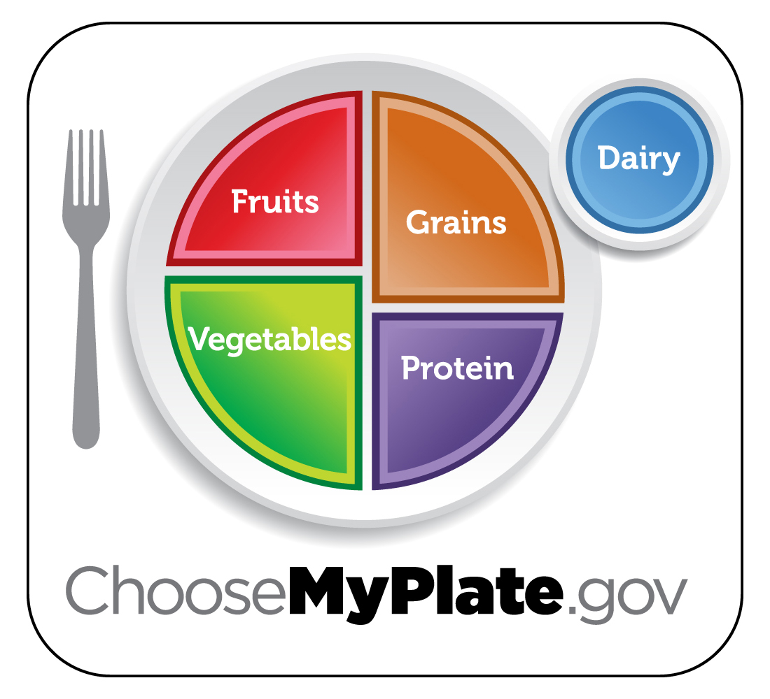
Caring about the
health of our Employees and customers

H
Fire and Ice Watermelon Salad Serving Size: 1½ cup Yield: 4 servings

Ingredients:
6 cups watermelon, rind removed, cut into large chunks
2 green onions, thinly sliced
⅓ cup thinly sliced red onion
⅓ cup torn mint leaves
1 tablespoon red pepper flakes
2/3 cup white vinegar
3 tablespoons vegetable oil
1 tablespoon chili powder

Preparation:
1. In a large bowl, combine watermelon, onions, mint, and red pepper flakes.
2. In a small bowl, mix vinegar, oil, and chili powder.
3. Drizzle vinegar mixture over watermelon mixture and serve.

Per Serving:
Calories 132, Total Fat 7g, Saturated Fat 1 g,
Sodium 12 mg, Protein 1 g

Eating fruit provides health benefits. Fruits provide nutrients vital for health and are naturally low in fat sodium and calories. None have cholesterol.

From the website of:

From the website of
http://www.cdc.gov/diabetes/pubs/pdf/ndfs_2011.pdf
2011

Health
focus

Caring about the
health of our Employees and customers

H
Fire and Ice Watermelon Salad Serving Size: 1½ cup Yield: 4 servings

Ingredients:
6 cups watermelon, rind removed, cut into large chunks
2 green onions, thinly sliced
⅓ cup thinly sliced red onion
⅓ cup torn mint leaves
1 tablespoon red pepper flakes
2/3 cup white vinegar
3 tablespoons vegetable oil
1 tablespoon chili powder

Preparation:
1. In a large bowl, combine watermelon, onions, mint, and red pepper flakes.
2. In a small bowl, mix vinegar, oil, and chili powder.
3. Drizzle vinegar mixture over watermelon mixture and serve.

Per Serving:
Calories 132, Total Fat 7g, Saturated Fat 1 g,
Sodium 12 mg, Protein 1 g

Eating fruit provides health benefits. Fruits provide nutrients vital for health and are naturally low in fat sodium and calories. None have cholesterol.

From the website of:

From the website of
http://www.cdc.gov/diabetes/pubs/pdf/ndfs_2011.pdf
2011

Health
focus

Caring about the
health of our Employees and customers

H
Fire and Ice Watermelon Salad Serving Size: 1½ cup Yield: 4 servings

Ingredients:
6 cups watermelon, rind removed, cut into large chunks
2 green onions, thinly sliced
⅓ cup thinly sliced red onion
⅓ cup torn mint leaves
1 tablespoon red pepper flakes
2/3 cup white vinegar
3 tablespoons vegetable oil
1 tablespoon chili powder

Preparation:
1. In a large bowl, combine watermelon, onions, mint, and red pepper flakes.
2. In a small bowl, mix vinegar, oil, and chili powder.
3. Drizzle vinegar mixture over watermelon mixture and serve.

Per Serving:
Calories 132, Total Fat 7g, Saturated Fat 1 g,
Sodium 12 mg, Protein 1 g

Focus on Fruits
include fruit at breakfast
At breakfast, top your cereal with bananas, peaches, or strawberries; add blueberries to pancakes; drink 100% orange or grapefruit juice. Or, try a fruit mixed with fat-free or low-fat yogurt.

try fruit at lunch
At lunch, pack a tangerine, banana, or grapes to eat, or choose fruits from a salad bar. Individual containers of fruits like peaches or applesauce are easy and convenient.

experiment with fruit at dinner, too
At dinner, add crushed pineapple to coleslaw, or include orange sections, dried cranberries, or grapes in a tossed salad.

snack on fruits
Dried fruits make great snacks. They are easy to carry and store well.

keep fruits safe

Rinse fruits before preparing or eating them. Under clean, running water, rub fruits briskly to remove dirt and surface microorganisms. After rinsing, dry with a clean towel.

Consider this...
Fresh fruit and vegetable consumption also provides an abundance of digestive and metabolic enzymes to the body. Enzymes are a type of protein that facilitate digestive and metabolic changes in the body. For example, after we eat something, it is enzymes that change the food into smaller particles that the body uses for maintenance and energy production.

http://www.improving-health-and-energy.com/
ChooseMyPlate.gov DG TipSheet No. 3,7 June 2011
USDA Center for Nutrition Policy and Promotion

University of Wisconsin, U.S. Department of Agriculture and Wisconsin Counties cooperating.
UW-Extension provides equal opportunities in employment and programming including Title IX and ADA.
Focus on Fruits
include fruit at breakfast
At breakfast, top your cereal with bananas, peaches, or strawberries; add blueberries to pancakes; drink 100% orange or grapefruit juice. Or, try a fruit mixed with fat-free or low-fat yogurt.

try fruit at lunch
At lunch, pack a tangerine, banana, or grapes to eat, or choose fruits from a salad bar. Individual containers of fruits like peaches or applesauce are easy and convenient.

experiment with fruit at dinner, too
At dinner, add crushed pineapple to coleslaw, or include orange sections, dried cranberries, or grapes in a tossed salad.

snack on fruits
Dried fruits make great snacks. They are easy to carry and store well.

keep fruits safe
Rinse fruits before preparing or eating them. Under clean, running water, rub fruits briskly to remove dirt and surface microorganisms. After rinsing, dry with a clean towel.

Consider this...
Fresh fruit and vegetable consumption also provides an abundance of digestive and metabolic enzymes to the body. Enzymes are a type of protein that facilitate digestive and metabolic changes in the body. For example, after we eat something, it is enzymes that change the food into smaller particles that the body uses for maintenance and energy production.

http://www.improving-health-and-energy.com/
ChooseMyPlate.gov DG TipSheet No. 3,7 June 2011
USDA Center for Nutrition Policy and Promotion

University of Wisconsin, U.S. Department of Agriculture and Wisconsin Counties cooperating.
UW-Extension provides equal opportunities in employment and programming including Title IX and ADA.
Focus on Fruits
include fruit at breakfast
At breakfast, top your cereal with bananas, peaches, or strawberries; add blueberries to pancakes; drink 100% orange or grapefruit juice. Or, try a fruit mixed with fat-free or low-fat yogurt.

try fruit at lunch
At lunch, pack a tangerine, banana, or grapes to eat, or choose fruits from a salad bar. Individual containers of fruits like peaches or applesauce are easy and convenient.

experiment with fruit at dinner, too
At dinner, add crushed pineapple to coleslaw, or include orange sections, dried cranberries, or grapes in a tossed salad.

snack on fruits
Dried fruits make great snacks. They are easy to carry and store well.

keep fruits safe
Rinse fruits before preparing or eating them. Under clean, running water, rub fruits briskly to remove dirt and surface microorganisms. After rinsing, dry with a clean towel.

Consider this...
Fresh fruit and vegetable consumption also provides an abundance of digestive and metabolic enzymes to the body. Enzymes are a type of protein that facilitate digestive and metabolic changes in the body. For example, after we eat something, it is enzymes that change the food into smaller particles that the body uses for maintenance and energy production.

http://www.improving-health-and-energy.com/
ChooseMyPlate.gov DG TipSheet No. 3,7 June 2011
USDA Center for Nutrition Policy and Promotion

University of Wisconsin, U.S. Department of Agriculture and Wisconsin Counties cooperating.
UW-Extension provides equal opportunities in employment and programming including Title IX and ADA.

