According to the Dietary Guideline for Americans, you should make half your plate fruits and vegetables.

From the website of:

From the website of
http://www.cdc.gov/diabetes/pubs/pdf/ndfs_2011.pdf
2011


Health
focus

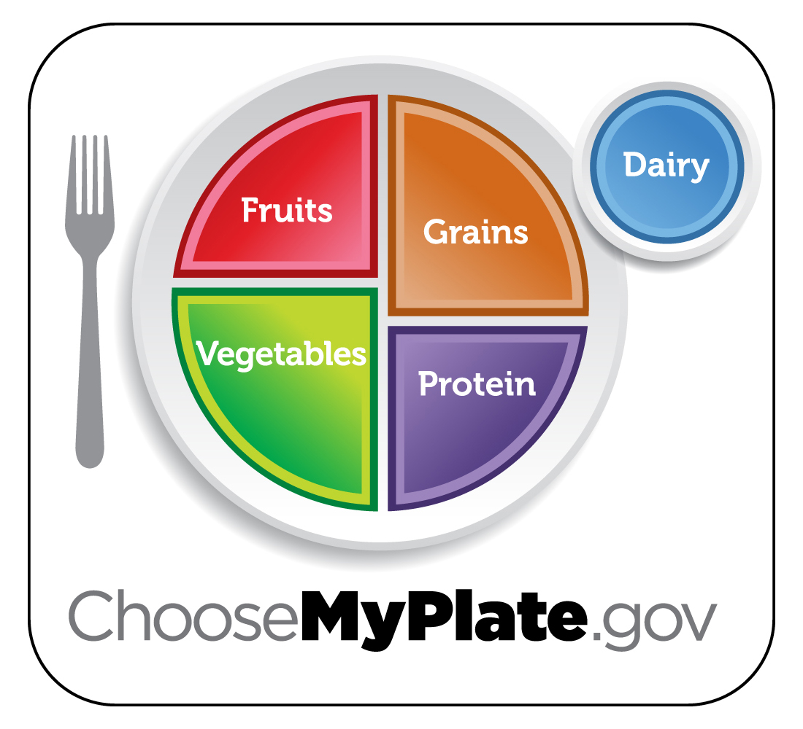
Caring about the
health of our Employees and customers

H
Outtasight Salad
Serving Size: 1 cup Yield: 4 servings

Ingredients:
2 cups salad greens of your choice
1 cup chopped vegetables (tomatoes, cucumbers,
carrots, green beans)
1 cup juice-packed pineapple chunks, drained, or fresh
orange segments
¼ cup Dressing (see below)
2 tablespoons raisins or dried cranberries
2 tablespoons chopped nuts, any kind
Preparation:
1. Put mixed salad greens on a large platter or in a salad bowl.
2. In a large bowl, mix chopped vegetables and pineapple or orange segments.
3. Add dressing and stir.
4. Spoon mixture over salad greens.
5. Top with raisins and nuts.

Foe Dressing: Mix ¼ cup nonfat, plain or flavored yogurt, 1 tablespoon orange juice, and 1½ teaspoons white vinegar

Per Serving:
Calories 100, Total Fat 2.5 g, Saturated Fat 0 g,
Sodium 30 mg, Protein 2 g

According to the Dietary Guideline for Americans, you should make half your plate fruits and vegetables.

From the website of:

From the website of
http://www.cdc.gov/diabetes/pubs/pdf/ndfs_2011.pdf
2011

Health
focus

Caring about the
health of our Employees and customers

H
Outtasight Salad
Serving Size: 1 cup Yield: 4 servings

Ingredients:
2 cups salad greens of your choice
1 cup chopped vegetables (tomatoes, cucumbers,
carrots, green beans)
1 cup juice-packed pineapple chunks, drained, or fresh
orange segments
¼ cup Dressing (see below)
2 tablespoons raisins or dried cranberries
2 tablespoons chopped nuts, any kind
Preparation:
1. Put mixed salad greens on a large platter or in a salad bowl.
2. In a large bowl, mix chopped vegetables and pineapple or orange segments.
3. Add dressing and stir.
4. Spoon mixture over salad greens.
5. Top with raisins and nuts.

Foe Dressing: Mix ¼ cup nonfat, plain or flavored yogurt, 1 tablespoon orange juice, and 1½ teaspoons white vinegar

Per Serving:
Calories 100, Total Fat 2.5 g, Saturated Fat 0 g,
Sodium 30 mg, Protein 2 g

According to the Dietary Guideline for Americans, you should make half your plate fruits and vegetables.

From the website of:

From the website of
http://www.cdc.gov/diabetes/pubs/pdf/ndfs_2011.pdf
2011

Health
focus

Caring about the
health of our Employees and customers

H
Outtasight Salad
Serving Size: 1 cup Yield: 4 servings

Ingredients:
2 cups salad greens of your choice
1 cup chopped vegetables (tomatoes, cucumbers,
carrots, green beans)
1 cup juice-packed pineapple chunks, drained, or fresh
orange segments
¼ cup Dressing (see below)
2 tablespoons raisins or dried cranberries
2 tablespoons chopped nuts, any kind
Preparation:
1. Put mixed salad greens on a large platter or in a salad bowl.
2. In a large bowl, mix chopped vegetables and pineapple or orange segments.
3. Add dressing and stir.
4. Spoon mixture over salad greens.
5. Top with raisins and nuts.

Foe Dressing: Mix ¼ cup nonfat, plain or flavored yogurt, 1 tablespoon orange juice, and 1½ teaspoons white vinegar

Per Serving:
Calories 100, Total Fat 2.5 g, Saturated Fat 0 g,
Sodium 30 mg, Protein 2 g
Add more veggies to your day
make your garden salad glow with color
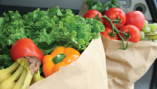
Brighten your salad by using colorful vegetables such as black beans, sliced red bell peppers, shredded radishes, chopped red cabbage, or watercress. Your salad will not only look good but taste good, too.
sip on some vegetable soup
Heat it and eat it. Try tomato, butternut squash, or garden vegetable soup. Look for reduced- or low-sodium soups.
while you’re out
If dinner is away from home, no need to worry. When ordering, ask for an extra side of vegetables or side salad instead of the typical fried side dish.
savor the flavor of seasonal vegetables
Buy vegetables that are in season for maximum flavor at a lower cost. Check
your local supermarket specials for the best-in-season buys. Or visit your local farmer’s market.
try something new

You never know what you may like. Choose a new vegetable—add it to your recipe or look up how to fix it online.

Consider this... Cucumbers are not a great source of vitamins or nutrients but they do contain lutein, a carotinoid that is essential in eye health.

Website Sources:
http://www.wisconsinfreshproduce.org/veg_facts.htm
ChooseMyPlate.gov DG TipSheet No. 7,8 June 2011
USDA Center for Nutrition Policy and Promotion

University of Wisconsin, U.S. Department of Agriculture and Wisconsin Counties cooperating.
UW-Extension provides equal opportunities in employment and programming including Title IX and ADA.

Add more veggies to your day
make your garden salad glow with color
Brighten your salad by using colorful vegetables such as black beans, sliced red bell peppers, shredded radishes, chopped red cabbage, or watercress. Your salad will not only look good but taste good, too.
sip on some vegetable soup
Heat it and eat it. Try tomato, butternut squash, or garden vegetable soup. Look for reduced- or low-sodium soups.
while you’re out
If dinner is away from home, no need to worry. When ordering, ask for an extra side of vegetables or side salad instead of the typical fried side dish.
savor the flavor of seasonal vegetables
Buy vegetables that are in season for maximum flavor at a lower cost. Check
your local supermarket specials for the best-in-season buys. Or visit your local farmer’s market.
try something new
You never know what you may like. Choose a new vegetable—add it to your recipe or look up how to fix it online.

Consider this... Cucumbers are not a great source of vitamins or nutrients but they do contain lutein, a carotinoid that is essential in eye health.

Website Sources:
http://www.wisconsinfreshproduce.org/veg_facts.htm
ChooseMyPlate.gov DG TipSheet No. 7,8 June 2011
USDA Center for Nutrition Policy and Promotion

University of Wisconsin, U.S. Department of Agriculture and Wisconsin Counties cooperating.
UW-Extension provides equal opportunities in employment and programming including Title IX and ADA.

Add more veggies to your day
make your garden salad glow with color
Brighten your salad by using colorful vegetables such as black beans, sliced red bell peppers, shredded radishes, chopped red cabbage, or watercress. Your salad will not only look good but taste good, too.
sip on some vegetable soup
Heat it and eat it. Try tomato, butternut squash, or garden vegetable soup. Look for reduced- or low-sodium soups.
while you’re out
If dinner is away from home, no need to worry. When ordering, ask for an extra side of vegetables or side salad instead of the typical fried side dish.
savor the flavor of seasonal vegetables
Buy vegetables that are in season for maximum flavor at a lower cost. Check
your local supermarket specials for the best-in-season buys. Or visit your local farmer’s market.
try something new
You never know what you may like. Choose a new vegetable—add it to your recipe or look up how to fix it online.

Consider this... Cucumbers are not a great source of vitamins or nutrients but they do contain lutein, a carotinoid that is essential in eye health.

Website Sources:
http://www.wisconsinfreshproduce.org/veg_facts.htm
ChooseMyPlate.gov DG TipSheet No. 7,8 June 2011
USDA Center for Nutrition Policy and Promotion

University of Wisconsin, U.S. Department of Agriculture and Wisconsin Counties cooperating.
UW-Extension provides equal opportunities in employment and programming including Title IX and ADA.

