People who eat more vegetables and fruits as part of an overall healthy diet are likely to have a reduced risk of some chronic diseases.

From the website of:

From the website of
http://www.cdc.gov/diabetes/pubs/pdf/ndfs_2011.pdf
2011


Health
focus

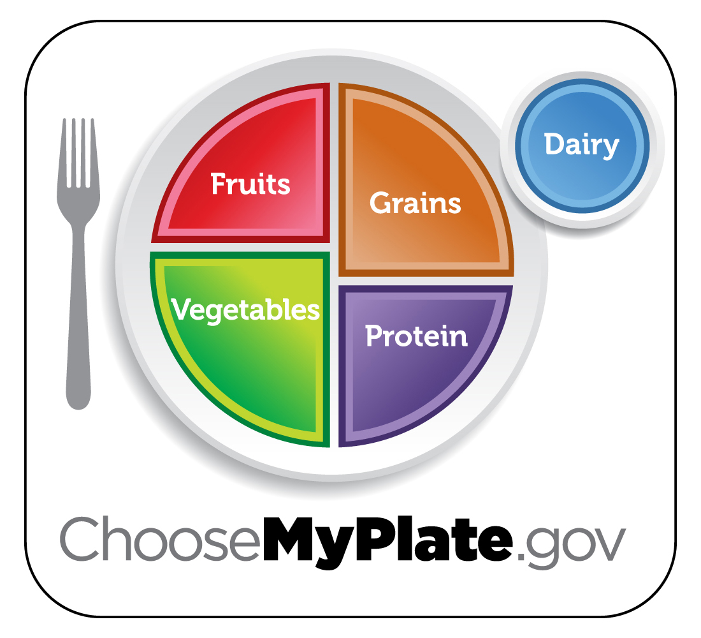
Caring about the
health of our Employees and customers

H
Frozen Fruit Cups
Serving Size: 1/18 of recipe Yield: 18 servings

Ingredients:
3 bananas, mashed
24 ounces yogurt, non-fat strawberry flavored
(or plain)
10 ounces strawberries, frozen, thawed,
undrained
1 can (8 ounces) crushed pineapple, undrained

Preparation:
1. Line muffin tin(s) cups with paper baking cups
(18 total).
2. In a large mixing bowl, add mashed bananas,
yogurt, strawberries, and pineapple.
3. Spoon into muffin tin and freeze at least 3
hours or until firm.
5. Remove frozen cups and store in a plastic bag in
the freezer.
6. Before serving, remove paper cups.

Per Serving:
Calories 50, Total Fat 0g, Saturated Fat 0 g,
Sodium 25 mg, Protein 2 g

People who eat more vegetables and fruits as part of an overall healthy diet are likely to have a reduced risk of some chronic diseases.

From the website of:

From the website of
http://www.cdc.gov/diabetes/pubs/pdf/ndfs_2011.pdf
2011

Health
focus

Caring about the
health of our Employees and customers

H
Frozen Fruit Cups
Serving Size: 1/18 of recipe Yield: 18 servings

Ingredients:
3 bananas, mashed
24 ounces yogurt, non-fat strawberry flavored
(or plain)
10 ounces strawberries, frozen, thawed,
undrained
1 can (8 ounces) crushed pineapple, undrained

Preparation:
1. Line muffin tin(s) cups with paper baking cups
(18 total).
2. In a large mixing bowl, add mashed bananas,
yogurt, strawberries, and pineapple.
3. Spoon into muffin tin and freeze at least 3
hours or until firm.
5. Remove frozen cups and store in a plastic bag in
the freezer.
6. Before serving, remove paper cups.

Per Serving:
Calories 50, Total Fat 0g, Saturated Fat 0 g,
Sodium 25 mg, Protein 2 g

People who eat more vegetables and fruits as part of an overall healthy diet are likely to have a reduced risk of some chronic diseases.

From the website of:

From the website of
http://www.cdc.gov/diabetes/pubs/pdf/ndfs_2011.pdf
2011

Health
focus

Caring about the
health of our Employees and customers

H
Frozen Fruit Cups
Serving Size: 1/18 of recipe Yield: 18 servings

Ingredients:
3 bananas, mashed
24 ounces yogurt, non-fat strawberry flavored
(or plain)
10 ounces strawberries, frozen, thawed,
undrained
1 can (8 ounces) crushed pineapple, undrained

Preparation:
1. Line muffin tin(s) cups with paper baking cups
(18 total).
2. In a large mixing bowl, add mashed bananas,
yogurt, strawberries, and pineapple.
3. Spoon into muffin tin and freeze at least 3
hours or until firm.
5. Remove frozen cups and store in a plastic bag in
the freezer.
6. Before serving, remove paper cups.

Per Serving:
Calories 50, Total Fat 0g, Saturated Fat 0 g,
Sodium 25 mg, Protein 2 g

Focus on Fruits
keep visible reminders
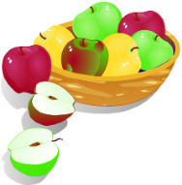
Keep a bowl of whole fruit on the table, counter, or in the refrigerator.

think about taste
Buy fresh fruits in season when they may be less expensive and at their peak flavor. Add fruits to sweeten a recipe.

think about variety
Buy fruits that are dried, frozen, and canned (in water or 100% juice) as well as fresh, so that you always have a supply on hand.

don’t forget the fiber
Make most of your choices whole or cut-up fruit, rather than juice, for the benefits that dietary fiber provides
.
be a good role model
Set a good example for children by eating fruit every day with meals or as snacks.

Consider this...
Fruits are rich in antioxidants. Antioxidants counteract aging effects, not just cosmetically but throughout the entire body. Fruits also strongly contribute to achieving an optimum pH balance of the body, which is critical to health and the prevention of illness. Fruits aid in creating this favorable internal environment where illnesses, such as cancer, cannot survive.

Sources:
http://www.improving-health-and-energy.com/
ChooseMyPlate.gov DG TipSheet No. 3,7 June 2011
USDA Center for Nutrition Policy and Promotion

University of Wisconsin, U.S. Department of Agriculture and Wisconsin Counties cooperating.
UW-Extension provides equal opportunities in employment and programming including Title IX and ADA.
Focus on Fruits
keep visible reminders
Keep a bowl of whole fruit on the table, counter, or in the refrigerator.

think about taste
Buy fresh fruits in season when they may be less expensive and at their peak flavor. Add fruits to sweeten a recipe.

think about variety
Buy fruits that are dried, frozen, and canned (in water or 100% juice) as well as fresh, so that you always have a supply on hand.

don’t forget the fiber
Make most of your choices whole or cut-up fruit, rather than juice, for the benefits that dietary fiber provides
.
be a good role model
Set a good example for children by eating fruit every day with meals or as snacks.
Consider this...
Fruits are rich in antioxidants. Antioxidants counteract aging effects, not just cosmetically but throughout the entire body. Fruits also strongly contribute to achieving an optimum pH balance of the body, which is critical to health and the prevention of illness. Fruits aid in creating this favorable internal environment where illnesses, such as cancer, cannot survive.

Sources:
http://www.improving-health-and-energy.com/
ChooseMyPlate.gov DG TipSheet No. 3,7 June 2011
USDA Center for Nutrition Policy and Promotion

University of Wisconsin, U.S. Department of Agriculture and Wisconsin Counties cooperating.
UW-Extension provides equal opportunities in employment and programming including Title IX and ADA.
Focus on Fruits
keep visible reminders
Keep a bowl of whole fruit on the table, counter, or in the refrigerator.

think about taste
Buy fresh fruits in season when they may be less expensive and at their peak flavor. Add fruits to sweeten a recipe.

think about variety
Buy fruits that are dried, frozen, and canned (in water or 100% juice) as well as fresh, so that you always have a supply on hand.

don’t forget the fiber
Make most of your choices whole or cut-up fruit, rather than juice, for the benefits that dietary fiber provides
.
be a good role model
Set a good example for children by eating fruit every day with meals or as snacks.
Consider this...
Fruits are rich in antioxidants. Antioxidants counteract aging effects, not just cosmetically but throughout the entire body. Fruits also strongly contribute to achieving an optimum pH balance of the body, which is critical to health and the prevention of illness. Fruits aid in creating this favorable internal environment where illnesses, such as cancer, cannot survive.

Sources:
http://www.improving-health-and-energy.com/
ChooseMyPlate.gov DG TipSheet No. 3,7 June 2011
USDA Center for Nutrition Policy and Promotion

University of Wisconsin, U.S. Department of Agriculture and Wisconsin Counties cooperating.
UW-Extension provides equal opportunities in employment and programming including Title IX and ADA.

